**Lower Hudson**

**Teacher Center Network**

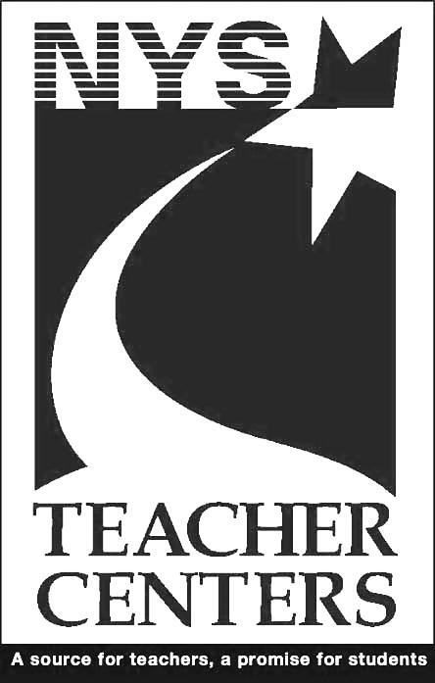

**Jump Start**

**National Board Certification**

**Foundations and Component 3**

**Wednesday, August 2, 2017**

**8:30AM – 4:30PM**

Location:

Rockland BOCES, Building 10 Professional Development Center, 65 Parrott Road, West Nyack, NY 10994

Co-Facilitators:

Colleen Napora, NBCT, Co-Regional Director,

Mid-Hudson Region, National Board Council of NYS

Ann Hovis- Williams, NBCT

Lunch provided by the

Lower Hudson Teacher Center Network.

Pre-registration required.

Click [here](https://www.mylearningplan.com/WebReg/ActivityProfile.asp?D=12361&I=2464275) to pre-register on MyLearningPlan at [www.rockteach.org](http://www.rockteach.org)

Questions:

Contact: Deborah Studnitzer, Rockland Teachers’ Center, dstudnitzer@rockteach.org

Get a **JUMP START** on achieving

National Board Certification with this one day training!

Free Training!

Mary Kunzmann, Co-Chair

Washingtonville Teacher Center

1314 Route 208

Washingtonville, NY 10992

Susan Farrell, Co-Chair

Edith Winthrop Teacher Center

475 W Hartsdale Ave

Hartsdale, NY 10530

Mary Beth Anderson

The Teacher Center of Central Westchester

Laura Crowley

White Plains Staff Development Center

Lori D’Andrea

Edith Winthrop Teacher Center

Lauren Benjamin

Bedford Staff Development Center

Mary Catherine Hillman

Ossining Staff Development Center

Lori Lawrence

Middletown Teacher Center

Jackie Levine

Hudson River Teacher Center

Vicki Liner

East Ramapo Teacher’s Center

Denise Lutter

Bronxville Staff Development Center

Ann Marie Nee

Scarsdale Teachers Institute

Michelle O’Sullivan

Nyack Teacher Center

Joe Pesavento

Mid-Hudson Teacher Center

Beverly Browne Fazio

Newburgh Teacher Center

Samantha Rosado-Cirello

Richard Gazzola Teacher Center of Yonkers

Susan Sniffen

Northern Westchester Putnam Teacher Center

Debra Thomas

Rockland Teachers’ Center

Judy Brink

Sullivan County Teacher Center

Ann Lenore Zalenski

New Rochelle Staff Resource Center

Mary Kunzmann, Co-Chair

Washingtonville Teacher Center

1314 Route 208

Washingtonville, NY 10992

Liz Hluchan, Co-Chair

Middletown Teacher Center

441 East Main St.

Middletown, NY 10940

Paula Acunto

East Ramapo Teacher’s Center

Mary Beth Anderson

The Teacher Center of Central Westchester

Robin Cohen

BEPT Teacher Center

George Crute

Bedford Staff Development Center

Paul J. Diamond

Richard Gazzola Teacher Center of Yonkers

Mary Catherine Hillman

Ossining Staff Development Center

Michelle Ifill-Rouseau

White Plains Staff Development Center

Denise Lutter

Bronxville Staff Development Center

Joanne Niebanck

Nyack Teacher Center

Ann Ostrowski

Hudson River Teacher Center

Joe Pesavento

Mid-Hudson Teacher Center

Barbara C. Scaros

Edith Winthrop Teacher Center

Susan Sniffen

Northern Westchester Putnam Teacher Center

Susan Taylor

Scarsdale Teachers Institute

Debra Thomas

Rockland Teacher’s Center

Ann Lenore Zalenski

New Rochelle Staff Resource Center

Newburgh Teacher Center

Carole O’Neill

Sullivan County Teacher Center